Final Exam (December 19, 2008)
Please read the problems carefully and answer them in the space provided. Write on the back of the page, if necessary. Show all your work. Partial credit will be given.

Problem 1 (6 pts, 3 pts/part ):

Part I: Initially polarized light is incident on a polarizer. If the intensity of the light after passing through the polarizer is ¾ of the initial intensity, the angle between the polarizer axis and the original polarization axis of the light is approximately

- 41.4 degrees
- 30 degrees
- 49 degrees
- 60 degrees

Part II: What is the maximum electric field amplitude for the initial light relative to the transmitted light?

Problem 2 (4 pts, show work):

Biff goes diving and shines an underwater searchlight at the surface of the water (index of refraction 1.33) with an angle of incidence of 32 degrees relative to the normal to the surface of the water. Buffy, sitting in a boat on the water, sees the light emerge from the water making an angle of how many degrees with respect to the normal to the surface of the water.

Problem 3 (3 pts) :

Ampere’s law is valid

- when there is a high degree of symmetry in the system.
- when there is no symmetry in the system.
- when the current is constant.
- when the magnetic field is constant.
- always.

Problem 4 (6 pts, 3 pts/part) :

A series RLC circuit with L=5 H, C=10 μF, and R =10 ohms is driven by a generator with a maximum emf of 100V and a variable frequency. The resonant frequency of this circuit is approximately

- 22 Hz
- /6
- /4
- /3
- /6
- /6
- /6
- /5
- /5
- /7
- /3
- /8
- /10
- /8
- /3
- /10
- /10
____________

tot /100

- 45 Hz
- 90 Hz
- 140 Hz
- 180 Hz
- 360 Hz

The maximum current in this circuit at resonance is approximately

- 3.2 A
- 5.3 A
- 7.6 A
- 9.5 A
- 10 A
- 12 A

Problem 5 (6 pts, show work) :

In the circuit to the right, what is the power dissipated in the 18 ohm resistor?
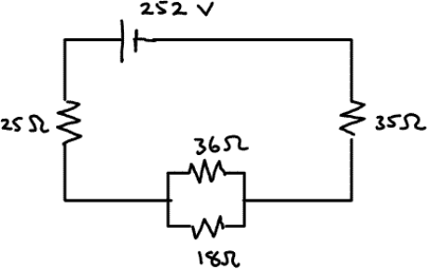

Problem 6 (6 pts, 3 pts/part) :

A capacitor is connected to a battery as shown. When a dielectric is inserted between the plates of the capacitor,

- only the capacitance changes.
- only the voltage across the capacitor changes.
- only the charge on the capacitor changes
- both the capacitance and the voltage change.
- both the capacitance and the charge change.

The energy stored in the capacitor after the dielectric is inserted is ______ the energy stored in the capacitor before the dielectric is inserted.

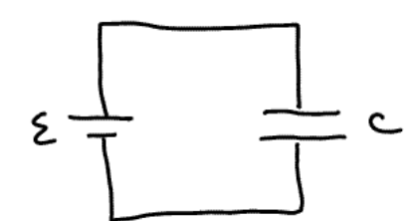
- less than
- equal to
- greater than

Problem 7 (5 pts, show work) :

Sammy charges a capacitor and then discharges it through a resistor. He notices that, after at time equal to two time constants passes, the voltage across the capacitor has decreased to roughly ____ of its value just prior to the initiation of the discharge.

- 0.368
- 0.135
- 0.0498
- 0.0183
- 0.00674

Problem 8 (5 pts) :
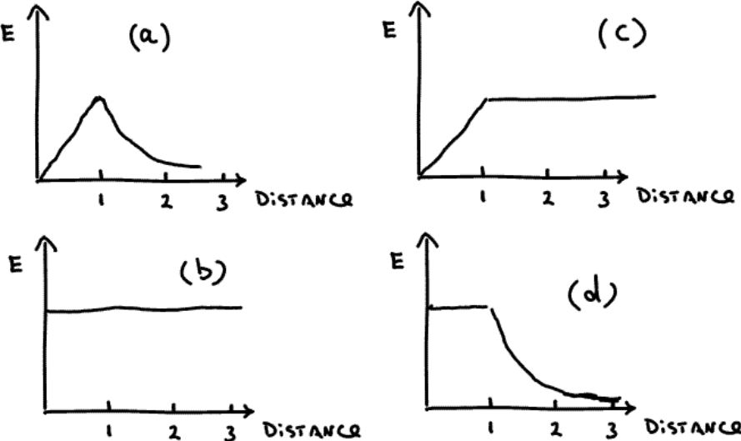
An infinite, insulating, slab of thickness one unit has a uniform volume charge density with x=0 at the center of the slab (the slab is oriented in the y-z plane). Indicate the graph at the right that best describes the electric field as a function of distance from the origin can be best represented by

Problem 9 (7 pts, show work) :

An object to the left of a lens is imaged by the lens on a screen 15.0 cm to the right of the lens. When the lens is moved 2.00 cm to the right, the screen must be moved 2.00 cm to the left to refocus the image. Determine the focal length of the lens.

Problem 10 (3 pts) :

The sketch below shows portions of four wires held at four different potentials V₁>V₂>V₃>V₄. The lines running from A to A’, B to B’, etc., represent four paths along which equal test charges are moved. The work involved in moving each of the charges along their respective paths is

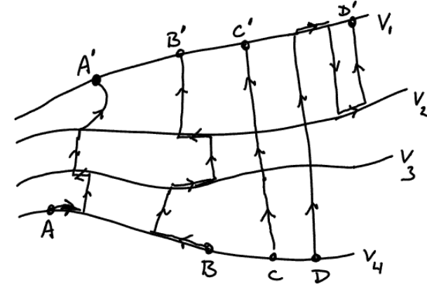
- largest for charge C.
- smallest for charge C.
- largest for Charge D.
- smallest for charge D.
- largest for charge A.
- smallest for charge A.
- largest for charge B.
- smallest for charge B.
- the same (nonzero value) for each path.
- zero for each path.

Problem 11 (8 pts, show work) :

After graduation the President calls you to Washington. With knees knocking you enter the oval office and discover why you’ve been summoned. The President says, “Because of your extreme physics prowess, I want you to help me evaluate a pet project of mine. You see, I love to watch Star Wars and other science fiction movies. You know how the characters in these movies have laser blasters that have the power to knock people back as if they were struck by a bullet? I really want one of those. I need your help in evaluating the feasibility of building a blaster like that.”

Briefly estimate here (for the President) the minimum power necessary for a blaster to emit (assume it emits light) in order that when the ray is incident on a person, it causes an acceleration of the person away from the blaster at 0.1g. Assume the blaster beam does not diverge significantly before hitting the target and also assume the cross section of the beam is much smaller than a human body. Finally, assume for now that the beam does not immediately blast a hole through the target.

Problem 12 ( 10 pts, show work) :

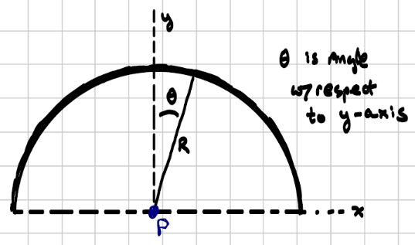
A non-conducting rod is bent into a semicircle as shown in the sketch to the right. Charge is distributed on this rod with a linear charge density λ=Aθ²/R, where A is a constant that makes the units work out correctly. Theta is the angle with respect to the y-axis as shown in the diagram. Determine the electrical potential at point P.

Problem 13 (8 pts, show work) :

A particle beam is created in a laboratory. A particle in the beam is created and lives for 25 ns in its rest frame before decaying. In the laboratory, that particle appears to travel 10 m in a straight line from the point of creation to the point of decay. Determine the speed of the particle in the laboratory.

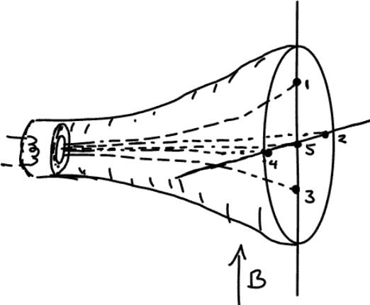
Problem 14 (3 pts) :

An electron beam is created in a standard cathode ray tube. Please indicate number that best indicates the location the electron beam will hit the screen.

Problem 15 (10 pts, show work) :
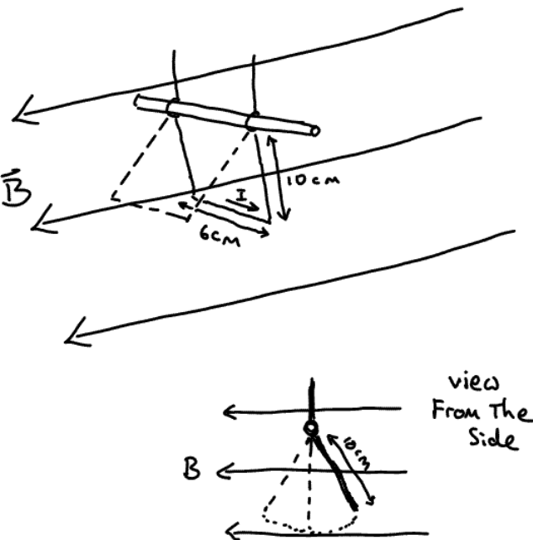
A rectangular frame is free to rotate about a horizontal shaft as shown in the sketch. The frame is 10 cm long and 6 cm wide and the rods that make up the frame have a mass per unit length of 20 g/cm. A horizontal, uniform magnetic field of 0.2 T is directed as shown in the figure. A current is of 8.0 A passes through the frame in the direction shown. If this frame is displaced slightly from the vertical plane and released, what is the period of oscillation for this ‘pendulum’? Assume the angle of displacement is small and that the rotation about the supporting shaft is frictionless.

Problem 16 (10 pts, show work) :

An infinite, straight, conducting wire with a cross-section illustrated in the sketch below carries a current I out of the paper. The current density, j, is constant. The wire has radius R. The wire has a coaxial cylindrical hole that has radius R/2 and is centered at x=R/2 as shown in the sketch.

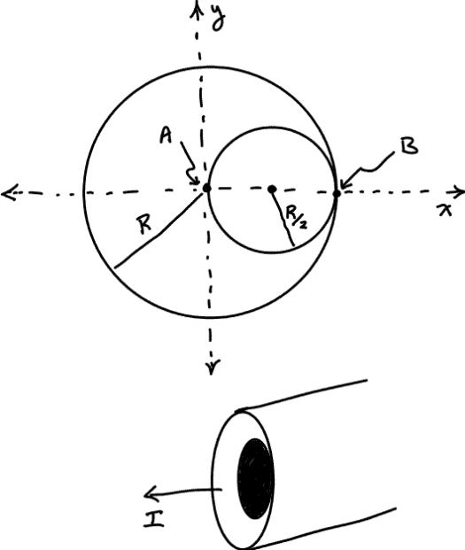
a) Determine the magnetic field at point B.

b) Determine the magnetic field at point A.

