Exam 1 (February 21, 2006)
Please read the problems carefully and answer them in the space provided. Write on the back of the page, if necessary. Show your work. Partial credit will be given.

Problem 1 (12 pts):

The figure below shows the path of a negatively charged particle (1) through a rectangular region of uniform electric field.

- Indicate the direction of the electric field in the rectangular region on the drawing. Indicate to the right of the drawing why you have chosen the direction you chose for the electric field.
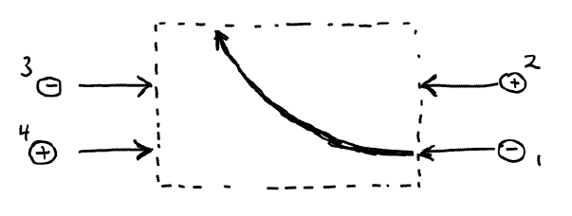
- Roughly sketch the paths that would be taken by particles (2), (3) and (4) as they pass through the rectangular region.

Problem 2 (12 pts):

Choose the diagram that corresponds to lines of constant potential around an electric dipole where the electric charges that make up the dipole are given by the positions of the large black dots. Justify your answer briefly to the right of the drawing.

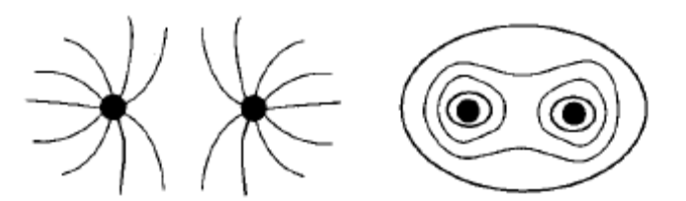

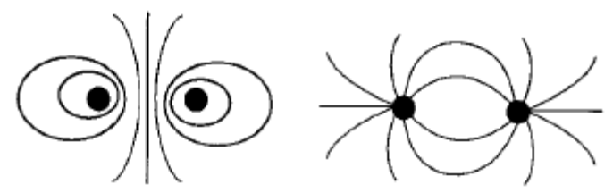

Problem 3 (12 pts):

A wire in the form of a circle of radius R lies in the plane of your paper. The half of the wire to the right of the dashed line carries a uniformly distributed positive charge. The half of the wire to the left of the dashed line carries a uniformly distributed negative charge which is the same in magnitude as the charge on the right side. The point P is at the center of the wire.

(a) Indicate on the sketch the direction of the electric field at point P.

(b) Calculate the electric potential at point P and justify your answer.
P

Problem 4 (14 pts):

After graduation you get a job at Sam’s Discount Furniture and Electrical Engineering Emporium. Sam was very impressed with your smile and your deep understanding of electromagnetism, as well as your flare for polishing oak coffee tables. During your first day on the job, a customer comes in and buys a lovely couch for her living room. While the couch is being packed in preparation for delivery, your customer wants you to explain a little something about electrostatics that has bothered her for years. Your customer expresses her question as follows:
- /12
- /12
- /12
- /14
- /15
- /15
- /20
____________

tot /100

“Can I shield the world from an electric charge by using a conductor? I mean suppose there is a big charge sitting in space. If I surround this charge by a thick, uncharged, conducting shell, will it eliminate the electric field outside the shell?”

Please provide below the answer you would give your valued customer under these circumstances. Feel free to use diagrams or equations as necessary.

Problem 5 (15 pts):

In the figure below, what electric charge can be placed at point P to insure that there is zero net electrostatic force on Q₃? Let the distance between Q₁ and Q₃ (as well as between Q₂ and Q₃) be 1 m. The distance between Q₃ and P is 1.4 m. (1 μC=10⁻⁶ C, k=9x10⁹ Nm²/C²)
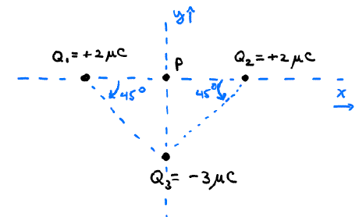

Problem 6 (15 pts):

A spherical, non-conducting, rubber balloon with radius R has a positive charge Q placed uniformly on its surface. The balloon is placed in a uniform electric field of 120 N/C. What is the net electric field inside the balloon? (Justify your answer)

Problem 7 (20 pts):

A non-conducting sphere of radius R carries a total electric charge of Q_{tot} distributed according to the volume charge density ρ(r)=A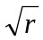 for r<R, where A is a constant, and ρ=0 for r>R.
(a) Determine (and circle) which of the following expressions is correct for A in terms of Q_{tot}. You must show how you determined this in order to get credit.

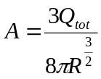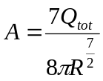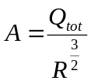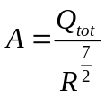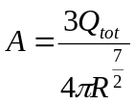

(b) Find the electric field in all space in terms of Q_{tot} (rather than A) as a function of r.

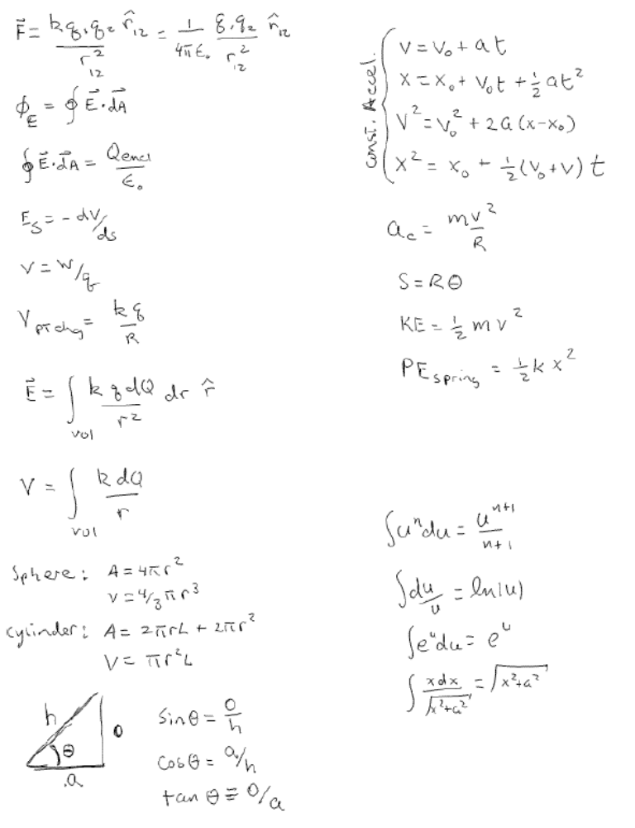

Potentially useful formulas

